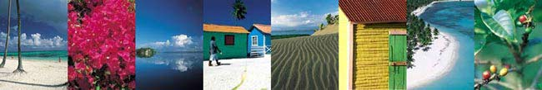
Overview
Barrio Willmore consists of prime, undeveloped real estate on the Samaná peninsula in the Dominican Republic with direct views of Samaná Bay (spawning area for North Atlantic Humpback Whales) and a variety of tropical fruit trees and flora within walking distance of the beach and two small islands joined by walking bridges. Barrio Willmore includes two large hills, including Maritani Hill consisting of 131 acres, ten acres of which will be donated to build Samaná College. Inmobiliaria Minaya y Willmore, S.A., a Dominican company led by CEO, Frank Minaya y Willmore, maintains singular control of Barrio Willmore landholdings.
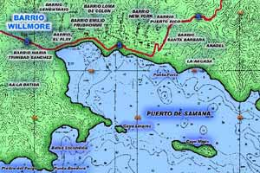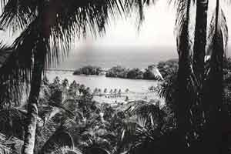
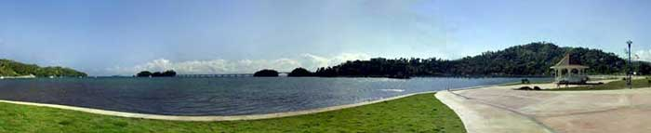
Samaná College
Inmobiliaria Minaya y Willmore, S.A. is currently in the process of obtaining government and private funding to build Samaná College: the first U.S.-sponsored, higher education study abroad facility in the Caribbean. The college will be built on ten acres of land on Maritani Hill, donated by Inmobiliaria Minaya y Willmore, S.A.

Working closely with the National Black Caucus of State Legislator’s/International Technical Assistance Center (NBCSL/ITAC) and U.S. Historically Black Colleges and Universities (HBCUs), Inmobiliaria Minaya y Willmore, S.A. and representatives of the International Educational Resource Center (IERC) are presently involved in efforts to encourage high-achieving students to participate in Pre-College and College study abroad programs in the Dominican Republic which focus primarily on Spanish as a Second Language. To request a copy of the Samaná College brochure (PDF file) or for more information regarding Samaná development opportunities, please contact Frank Minaya y Willmore at frankminaya@samanacollege.com.

For More Information
- For more information regarding doing business in the Dominican Republic, click here.
- For Samaná Hotels and Accommodations, click here.
- For general information regarding Samaná, Dominican Republic, click here.
- For 360°, panoramic images of Samaná, Dominican Republic click here.
- For more information regarding Dominican Republic study abroad opportunities, click here.

